**SITE PLAN FOR CHAMBER OF COMMERCE SITE**

**SITE NAME**

The name of the website is “KponeChamberofCommerce.com”.

**SITE PURPOSE**

The purpose of this site is to provide a platform for businesses in the Kpone Katamanso district of Ghana to network with one another to promote the development and success of involved businesses, and ultimately, to foster the development of the district

**TARGET AUDIENCE**

A description for the target audience for this site is as follows:

* **Who:** Business owners, investors, tourists, government workers
* **Age:** 20 – 100years
* **Technology:** Laptops and Desktops, Moderate internet connection speed, Mobile phones
* **Income:** Audience is comprised of users with varying incomes, ranging from minimum wage earners to business owners.
* **Motivation:** People will visit this site to get information about businesses in the district, and to explore businesses and investment opportunities in the area.

**PERSONAS**



* **Name: Alice M. Nortey**
* **Occupation:** Entrepreneur (Provision store owner)
* **Demographics & Education:** 30 years old. Completed Senior High School. Has worked as a trader for many years and now owns her own provision store.
* **Purpose for site visit:** Looking for opportunities to expand her business.
* **Technology:** Is accustomed to using her mobile phone for most of her browsing activities.
* **Quote:** “I can work as long as I can think.”



* **Name: John Greene**
* **Occupation:** Marketer
* **Demographics & Education:** 45 years old. Has a Master’s degree in marketing.
* **Purpose for site visit:** Looking for opportunities for his company to partner with local businesses.
* **Technology:** Is very tech-savvy. Prefers to patronize ISPs with the fastest internet speeds, no matter the cost.
* **Quote:** “Experience is indeed, the best teacher.”

**SITE MAP**

Below is an image describing how various pages on the site are linked:

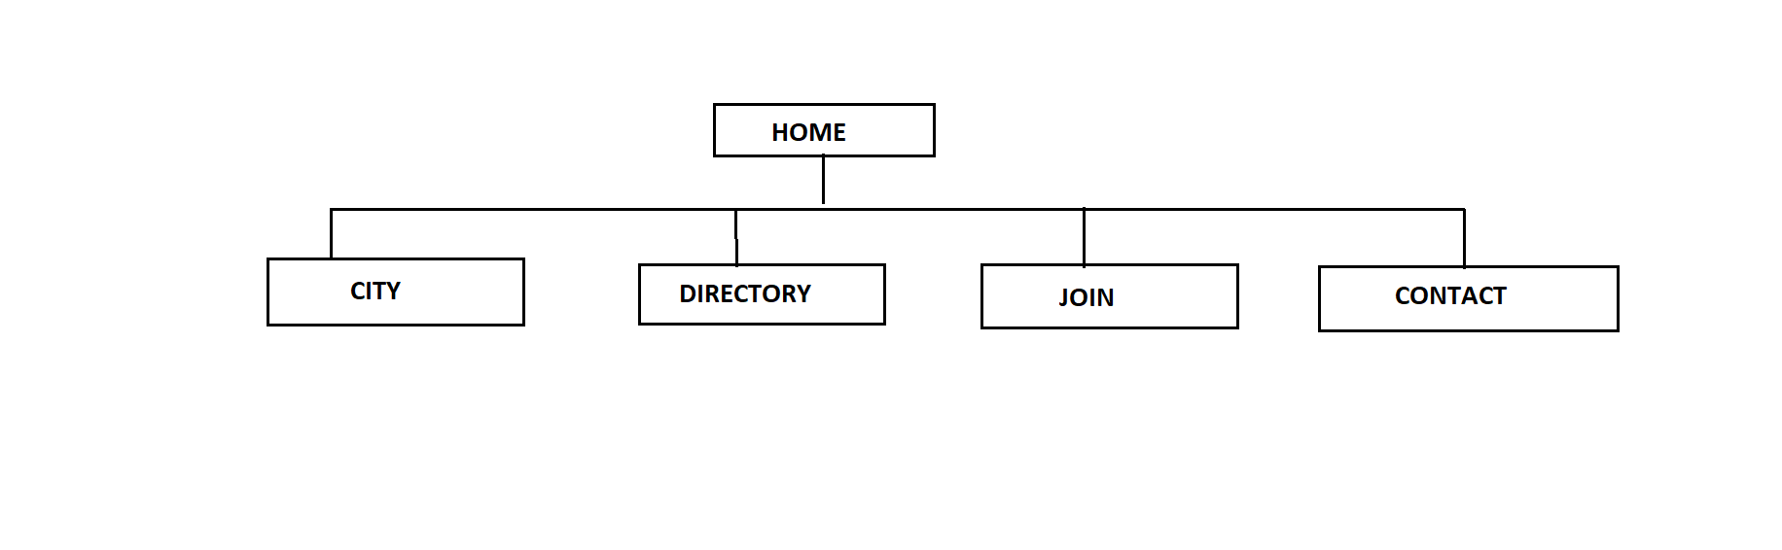

**COLOR SCHEME**

The colors to be used in the site are :

* Isabelline(#F2EFEA)
* Outrageous Orange(#FC7753)
* Zomp(#2CA58D)
* Straw(#DBD56E)

This is link to a color palette of the selected colors from coolors.co: <https://coolors.co/f2efea-fc7753-2ca58d-dbd56e>

**Typography**

The following table describes the font, font size, line height, and styles to be used in this site.

|  |  |  |  |
| --- | --- | --- | --- |
| OBJECT | FONT | SIZE | COLOR |
| Default Paragraph Text(p) | Josefin Sans | default | #000000 |
| Heading text (h1, h2) | Gluten | default | Outrageous Orange (#FC7753) |
| Navigation Anchor Selected | Josefin Sans | 1.5em | Outrageous Orange (#FC7753) |
| Navigation Anchor Unselected | Josefin Sans | 1.5em | Zomp(#2CA58D) |

**Navigation**

Navigation will be near the top of the page with the following color scheme

* Unselected link will be Zomp(#2CA58D) in straw(#D8D56E) background
* Link being hovered on will have a reverse color scheme as unselected link
* Selected link will have denim Outrageous Orange(#FC7753)

**WIREFRAMES**

**LARGE AND MEDIUM VIEWS**

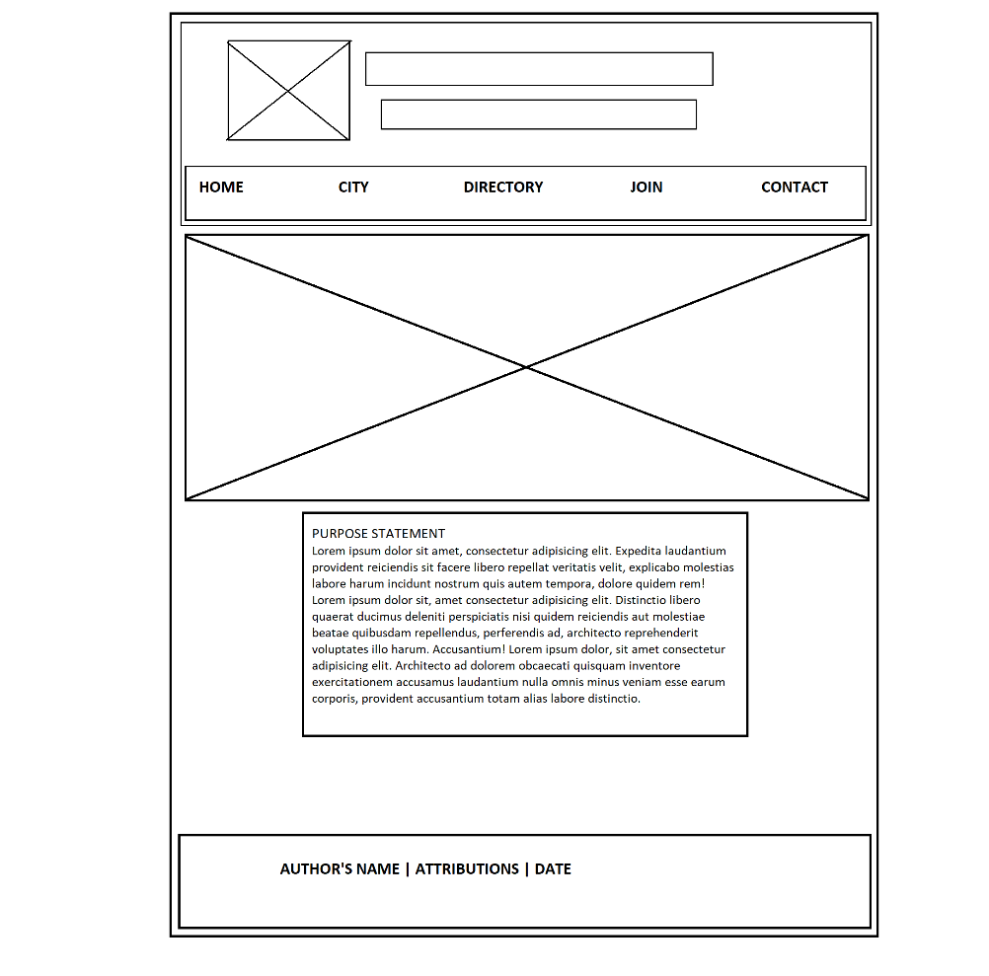

**SMALL VIEW**

